- Go to ICCOP to search-- CTRL + F then search facility code. Make sure it's always "within: Workbook" then FIND ALL
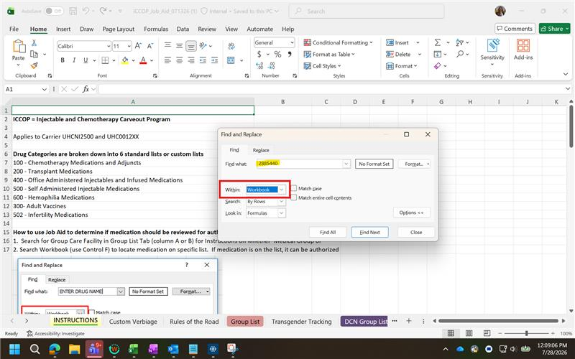
- Go to Group List to check for matching facility code--highlight then search for drug
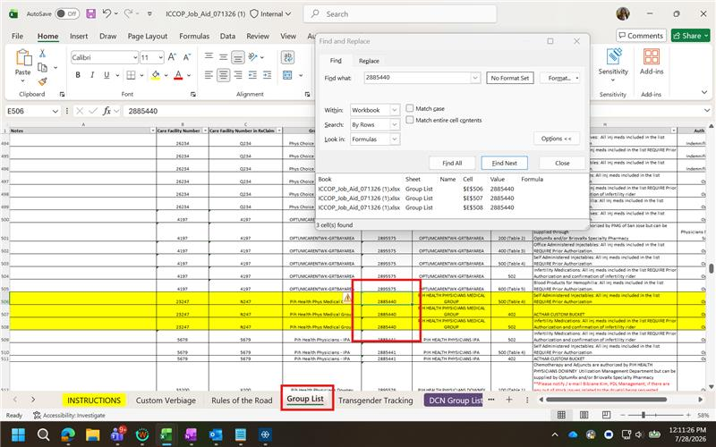
- Search for drug and check for matching list-- Wegovy is in list 500 and there's matching 500 on the facility code
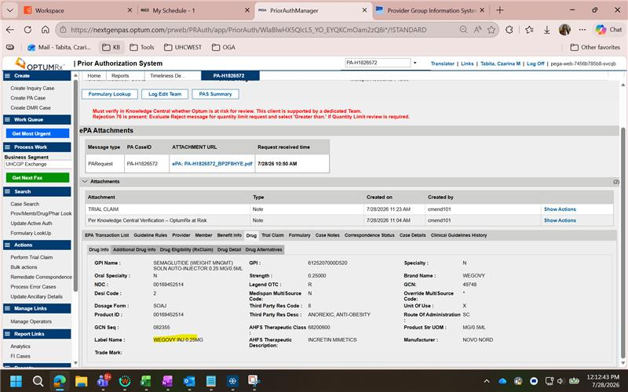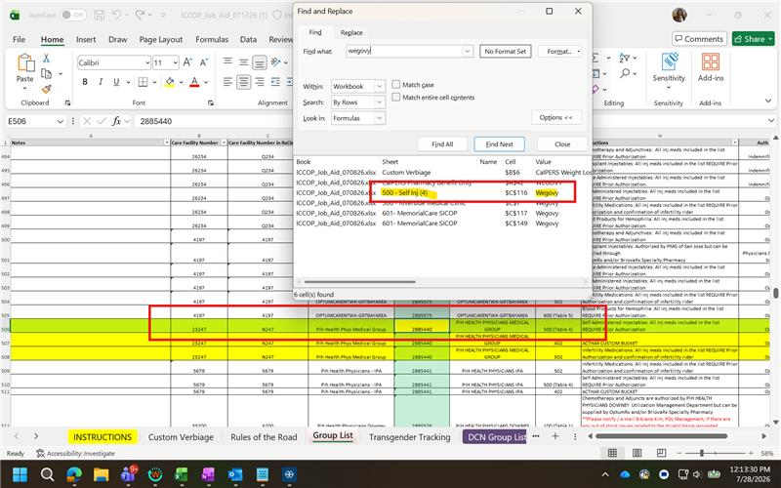
- If there is a matching list, check if Optum is at risk for review and supply--
Auth Delegation-Review
Fulfillment- Supply
- Optum at risk for review and supply
